# Nanopore technology

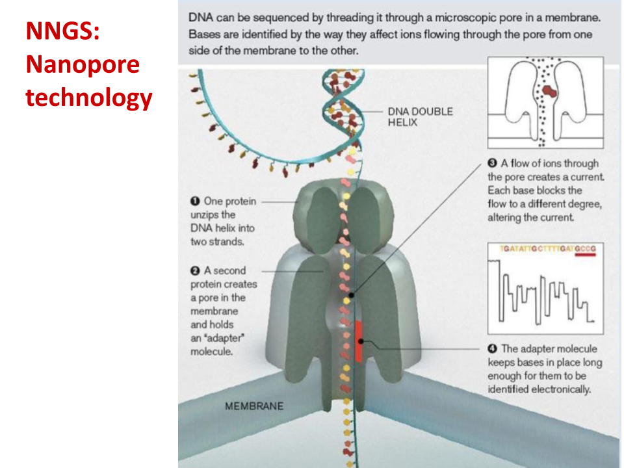

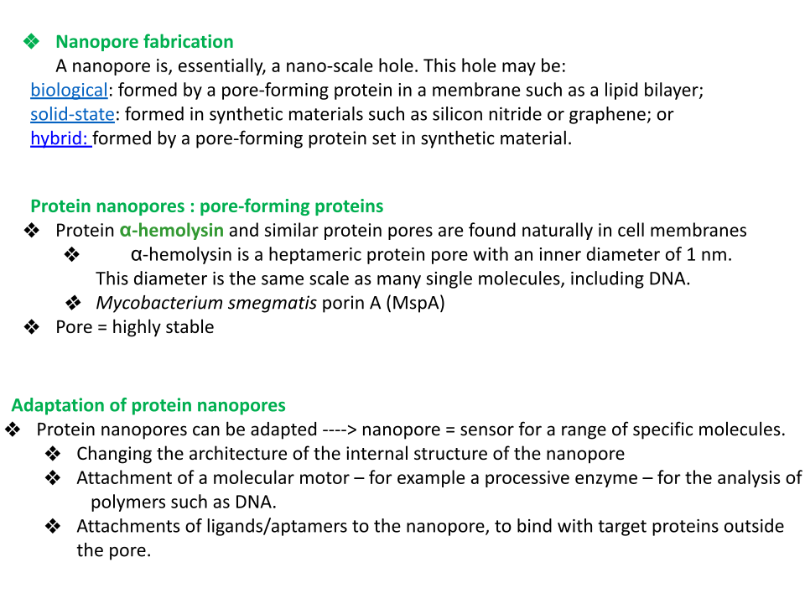

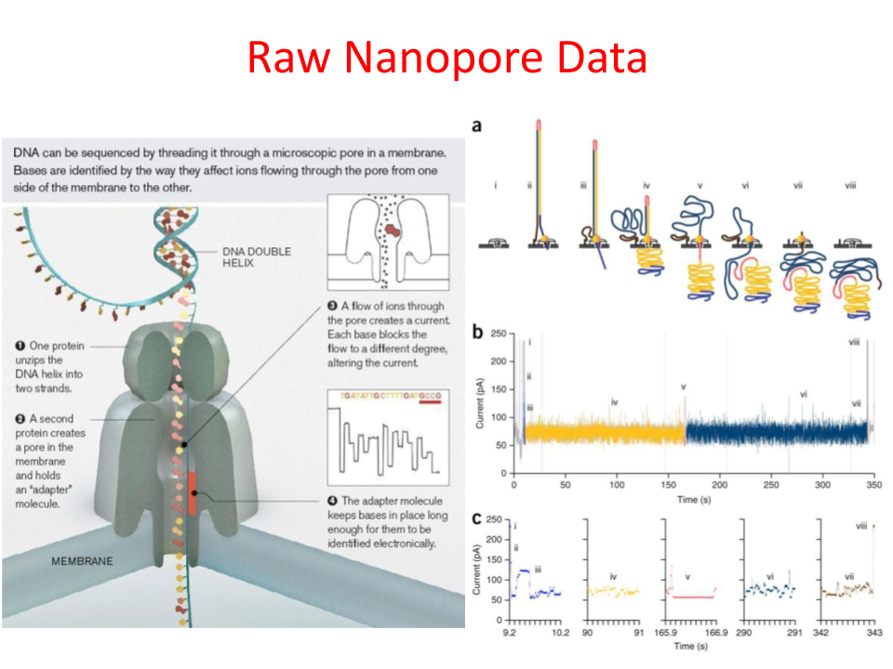

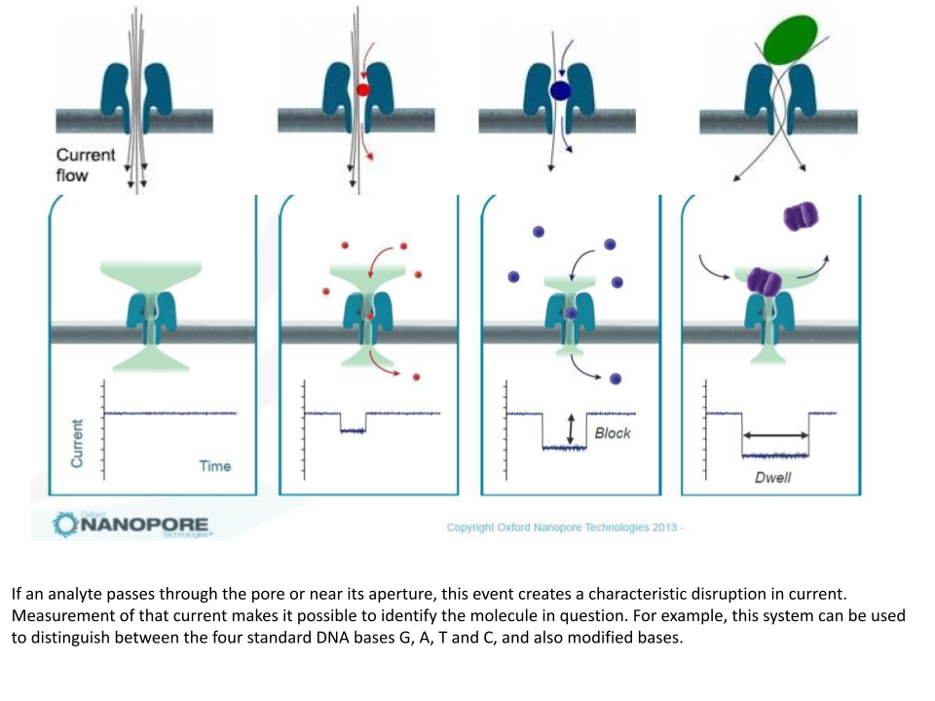

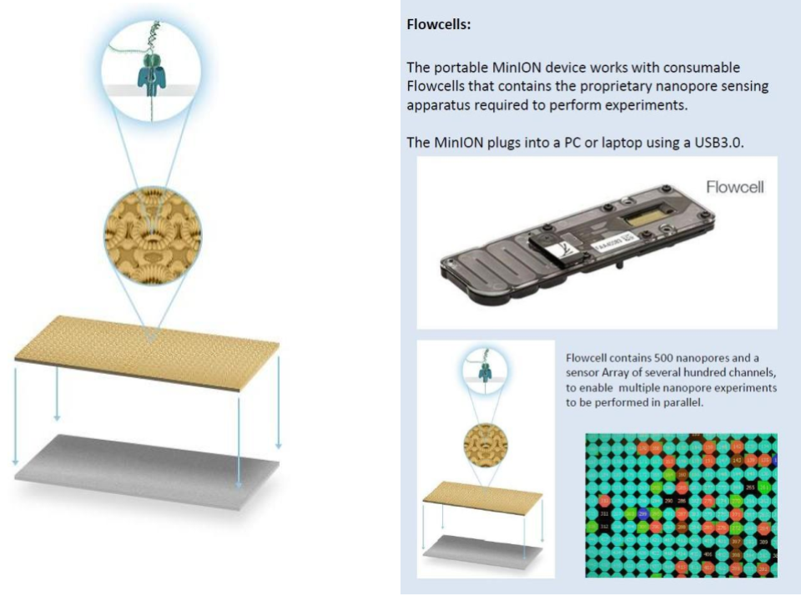

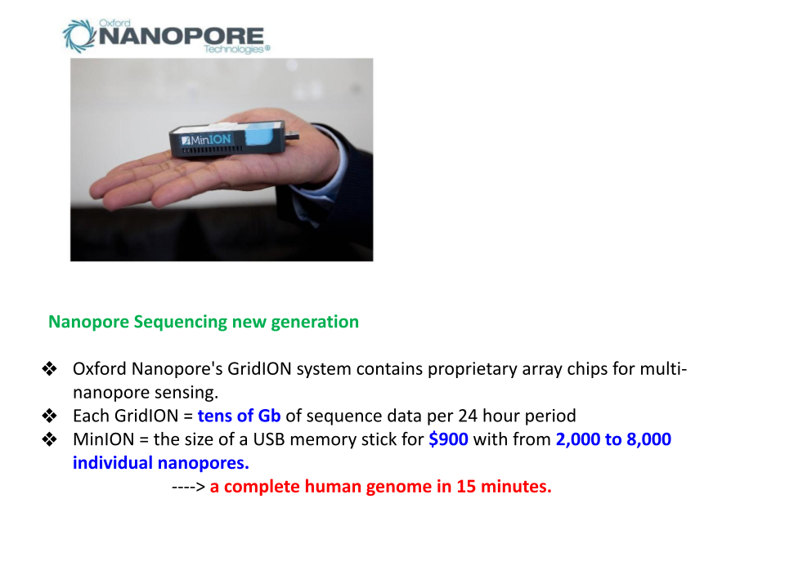

# Dynamic Genome

* In order to analyse a specie’s history through evolution, you have to consider consequential evolutionary mutation events.

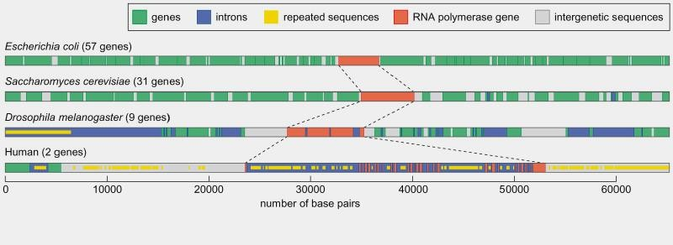

* The above image represents a genomic comparison between different species:
  + The prokaryote has higher gene density, low intergenic regions.
  + Unicellular eukaryotes continue to have high gene density, with low integenic regions and very low presence of introns.
  + The drosophila however, observe introns within their genetic sequences, more intergenic regions and repetitive sequences, **even within the intron**.
  + The human genome is the most complex.
* Plant genomes particularly have an added complexity of a tendency in massive repetitive regions within their genome.
* **Transcriptomic problems**: Genes that are not included in the transcriptomic analysis, but are apparent during annotation, could be ones which are no longer expressed due to functional loss or redundancy, or a genetic sequence that is **bound to become functional** and is **slowly evolving**.
* Organisms have distinct **Guanine and Cytosine** contents, even within a species. (**G+C**).
* **Gene size** in complex organisms/genomes are **larger due to the abundance of introns**, **intergenic regions**, etc.
* Gene frequency is an indicator of the presence of **multiple gene clusters** in complex genomes. Higher the **kb per gene**, higher chance of clustering and intergenic/dark regions.

# Transposable elements (General)

* DNA sequences that can move within the genome
* More than half of the DNA in eukaryotes
* **Two major classes**:
  + **Transposons**: Move via a cut and paste system
  + **Retrotransposons**: Move via an intermediary
* **Play a role in the evolutionary capacity of "massive and messy genomes" such as those of plants**. All of the following are random events which alongside evolutionary mutations, can lead to positive, or possibly negative, implications in the genome.
  + Creating new genes
  + Potentially destructive
  + Gene editing
  + Gene programming or re-programming
* Transposition leads to genome expansion
* Transposition is done in real time: differences between lines or descendants

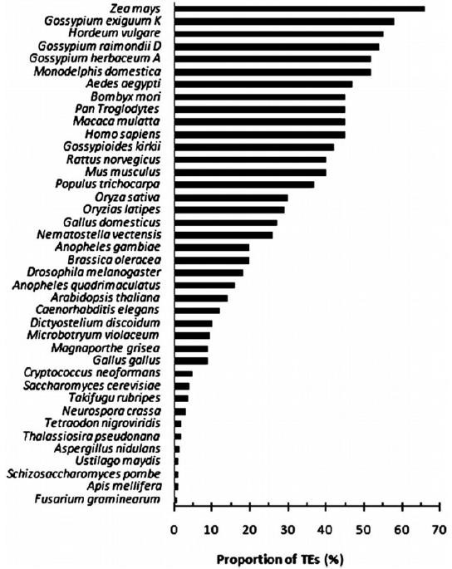

Additional information on (TEs)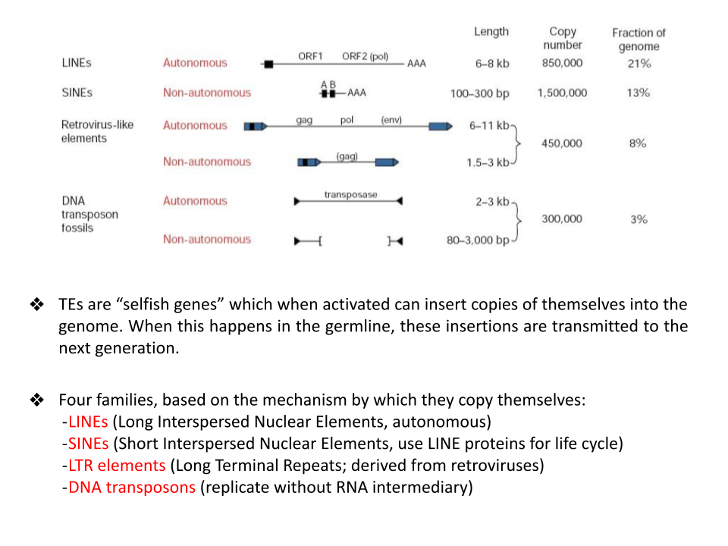

* APC gene, for ex. Has a transposable element which can lead to colon cancer.

# Forms of transpon effect to genomic structure

* The process shown here will take multiple generations, the integration of the TE is obviously not instant, but can cause instant repercussions on a somatic scale.
* 4% of the human genome has undergone genetic modifications through movement of a TE.
* TEs can also, obviously,replace other TEs, either completely or most often partially, complicating annotation.
* Using these historiographic analysis of TE movement, one can determine the point of divergence within a genus of X.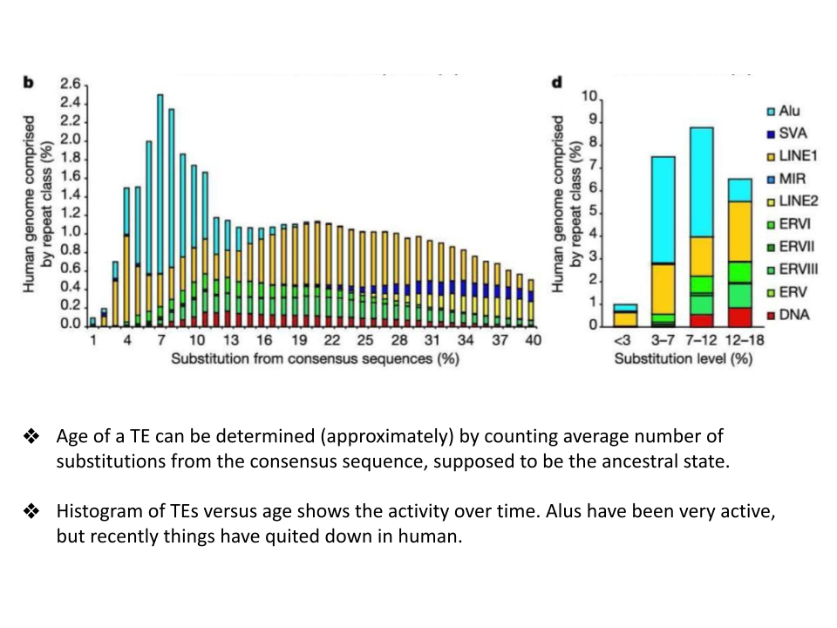
* The particular difficulty in identifying ancestral families is in what percentage of similarity is considered acceptable. How do you know, considering all of the factors of evolution, when divergence occurred.
* Gene families ensure that certain functions in the organism, involving regulating expression of the genes themselves, is handled by the multiple, slightly dissimilar members of the gene family.

# Synteny

**Synteny** refers to the elements within two different genomes, which overlap on KB basis. These **overlapping sequences**, are **highly similar**, they cannot be identical, they are called **Syntenic Blocks**.

When synteny during comparative genomics, stretches over a **long** **KB distance**, this is called **Macrosynteny**.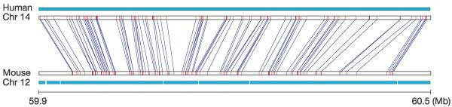

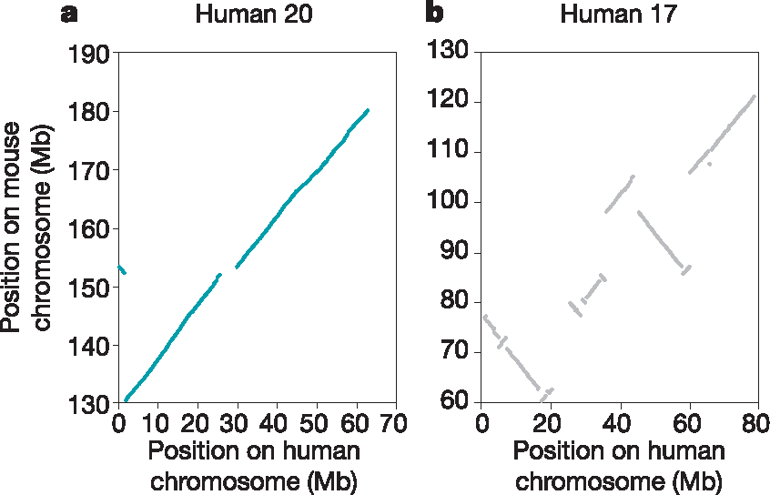

**IMPORTANT**

In picture a, the two chromosomes are **highly syntenic**, of which **genetic elements are in the same order**. Whereas in picture b, the chromosomes are **not syntenic**, as they **do not form a linear** graph.

* **Microsynteny** refers to **small gene clusters** which can overlap, or be equated to each other between different organisms.

# Genomic Duplication

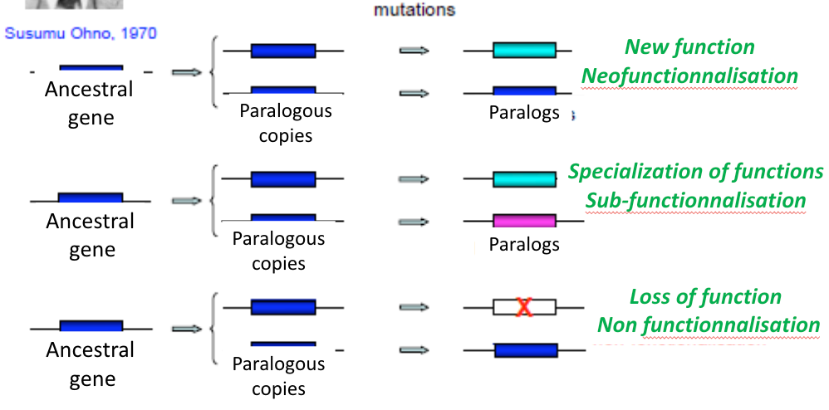

Apart from structural genomics, functional genomics are required to determine the functional changes between genome copies.

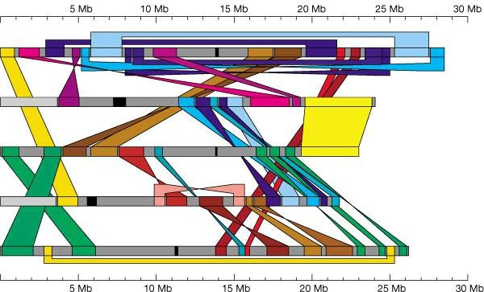

The connecting regions are copies of one chromosome onto another. Genomic rearrangement, genomic **segmental** duplication.

Smaller segments of DNA duplication are called **satellites**.

* **Orthologs**: Different species, but **high sequence similarity**, **different** **ancestry**.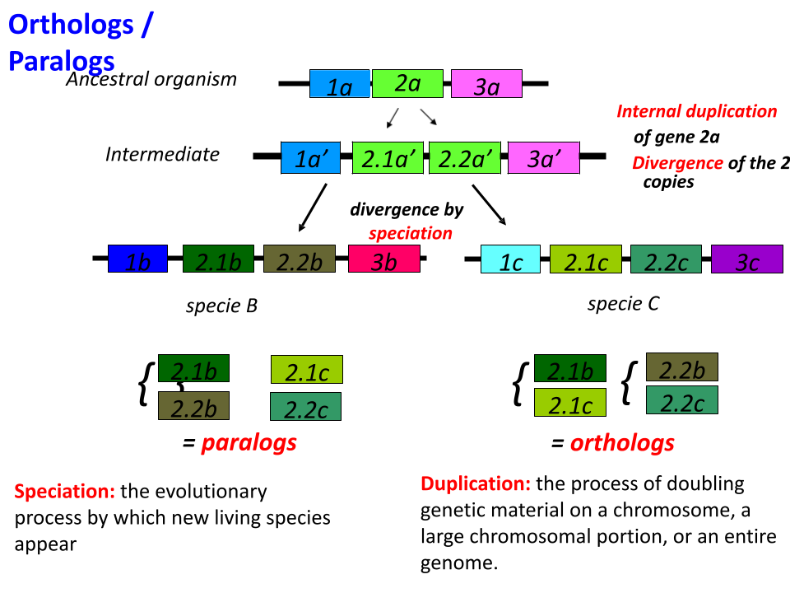
* 2.1a and 2.2a are **duplicates** of 2a.
* **Paralogs**: Within the same species, **high sequence similarity** but have **common ancestry**. **Not a complete copy**.
* **Core genome**: The genome which is present within all species that have **common ancestry**.
* How to find orthologs? Using an algorithm to identify **reciprocal hits**, during comparative genomics. That is, to find sequences in different species which when cross referenced, are similar, despite their rearrangements in the genome, TEs, etc.